

**Cosmic Heat: 2D Space Shooter**

**T. Y. B. Sc. Computer Science**

**CIE 3 Computer Graphics**

**By**

**Vivek Kumar Shriwas**

**202100756**

**2023-2024**

**Pursued in**

**Department of Computer Science**

**Faculty of Science & Technology**

**Vishwakarma University, Pune**

**Project Report**

**Project Title:** Cosmic Heat: 2D Space Shooter

* **Project Objectives:**

The objective of the project is to create an engaging 2D space shooter game using Python and Pygame. The game should feature player-controlled spacecraft, challenging enemies, epic boss battles, and intuitive controls. Continuously update and improve the game for enhanced gameplay and user experience.

* **Project Description:**

"Cosmic Heat" is a 2D space shooter game developed in Python using the Pygame library. The game offers an immersive space adventure where players take control of a spacecraft and navigate through waves of enemy ships while facing epic boss battles. The game provides an action-packed experience with the following features:

* + Player-controlled spacecraft with keyboard and joystick support.
  + Intuitive controls: Use arrow keys for movement, SPACE key to shoot, P to pause, and Esc to exit the game.
  + Diverse and challenging enemies, creating an engaging gameplay experience.
  + Multiple epic boss battles to test the player's skills.
  + Continuous updates to improve gameplay, add new features, and fix any issues.
* **Project Outcome:**

The project has successfully developed "Cosmic Heat," a 2D space shooter game. Key outcomes and achievements include:

* + A fully functional and engaging game with smooth gameplay.
  + Player-controlled spacecraft with responsive controls.
  + A variety of challenging enemy ships and epic boss battles.
  + Regular updates to enhance the game's features, fix bugs, and provide an evolving gaming experience.
* **Output Screenshots :**
* **Screenshot 1**: Gameplay

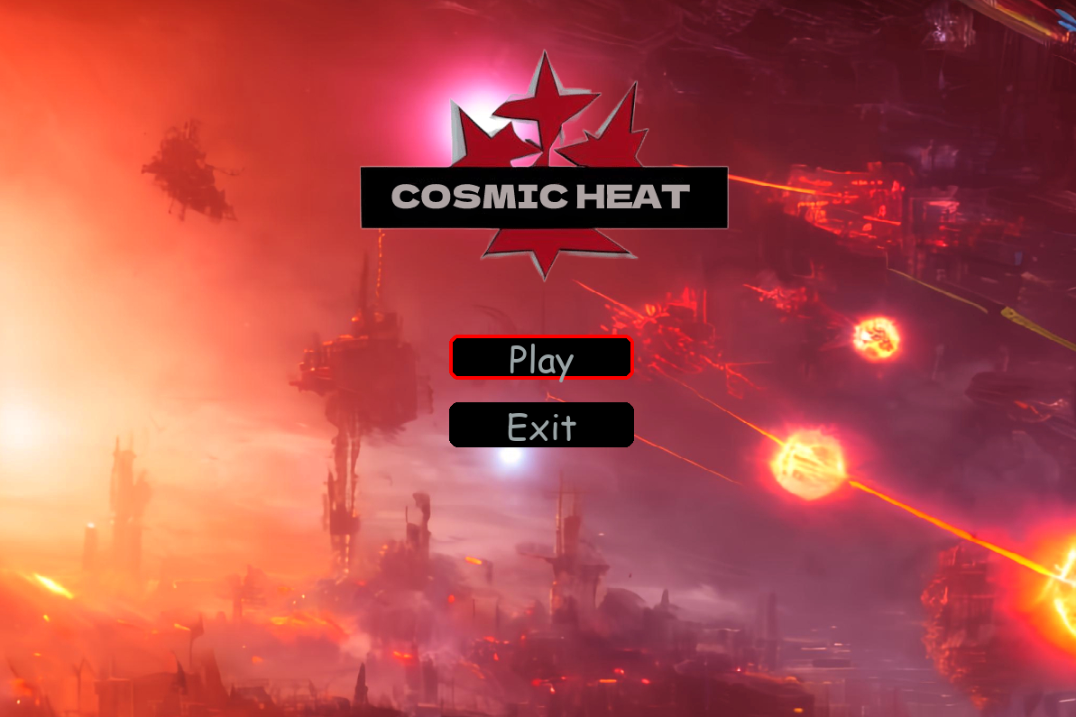

* **Screenshot 2:** Epic Boss Battle

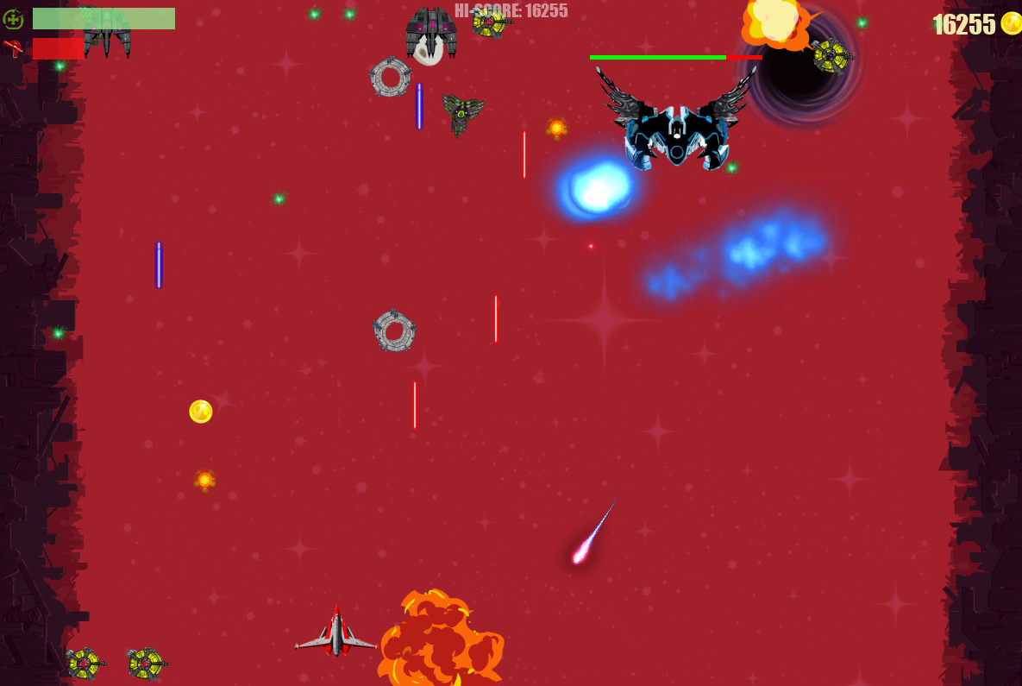

* **Screenshot 3:** Player in Action

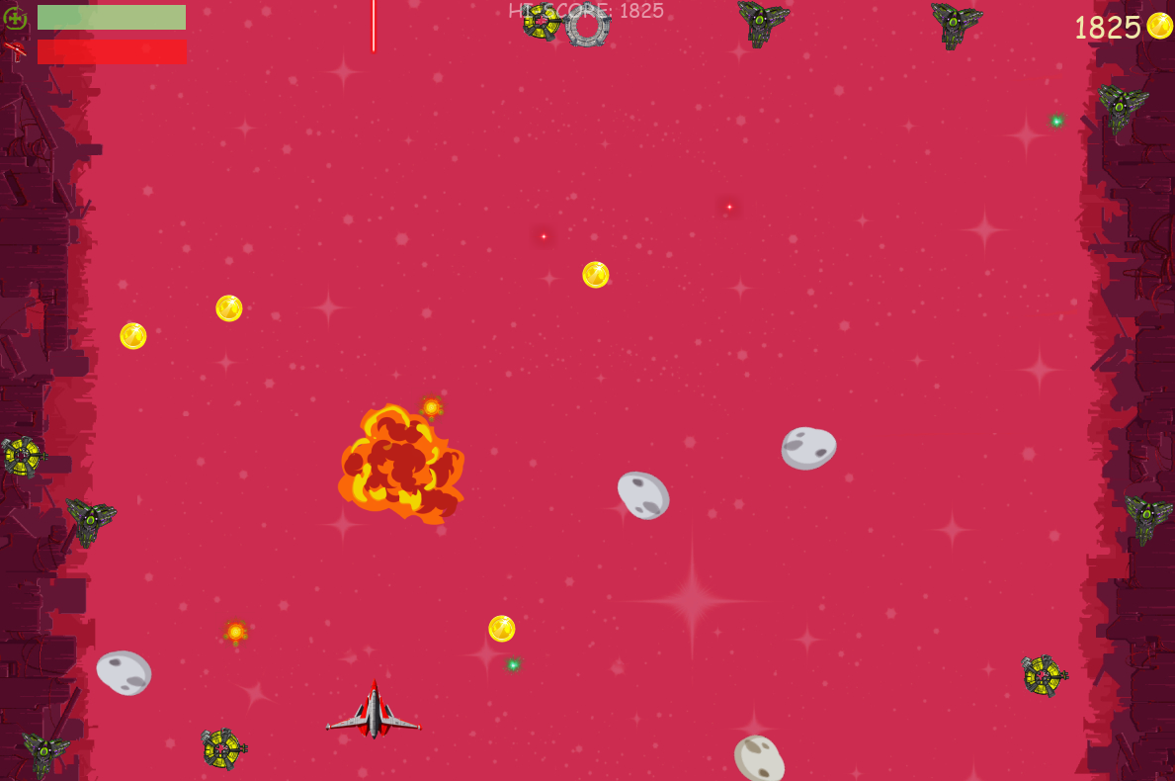

* **Screenshot 4:** High-Intensity Space Combat

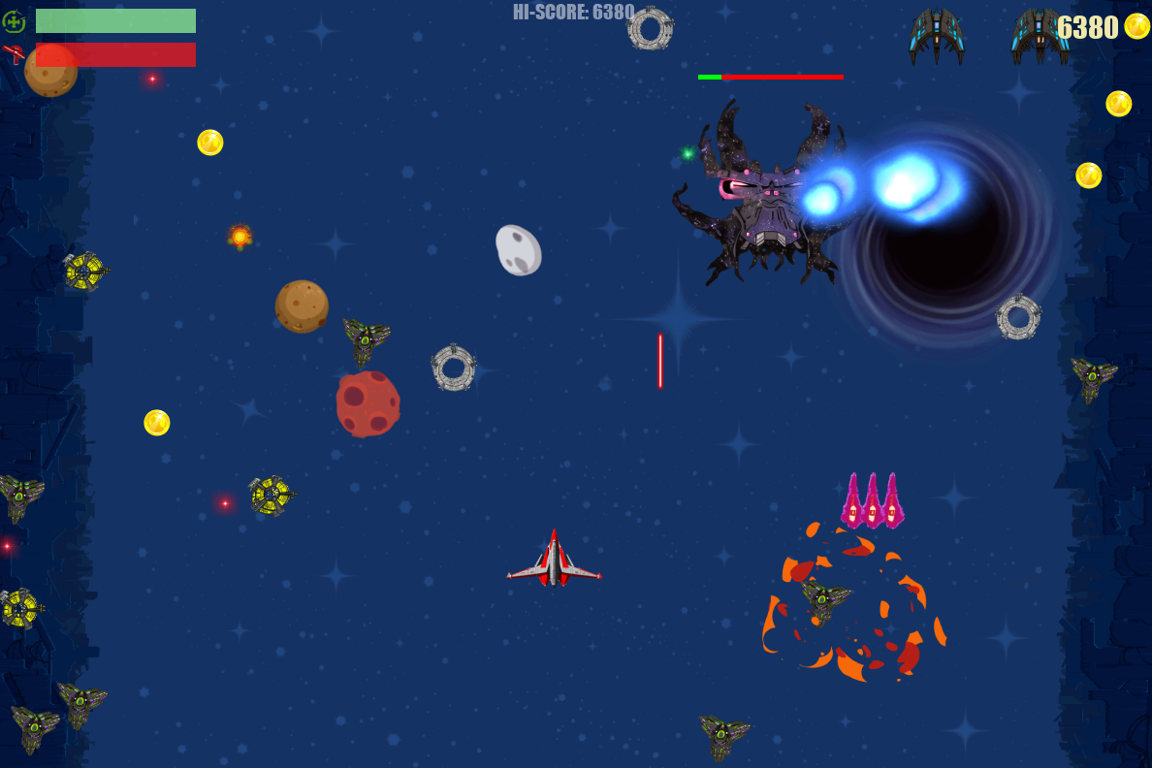

* **Screenshot 5:** Game Over Screen

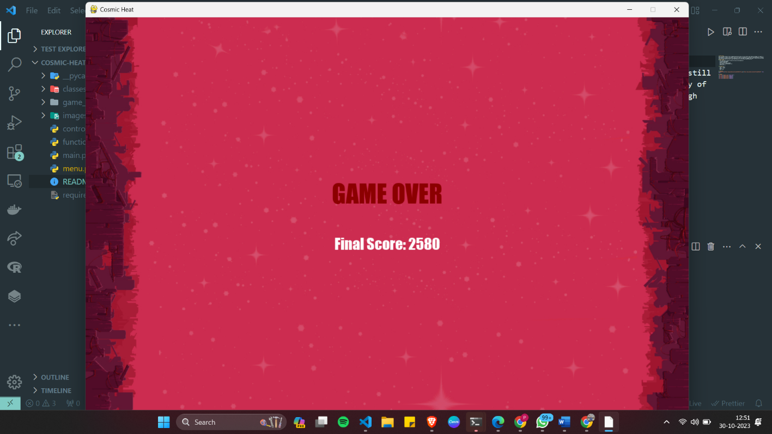

* **Conclusion:**

The "Cosmic Heat" project has met its objectives by delivering an exciting 2D space shooter game. It provides an immersive gaming experience with engaging gameplay, player-controlled spacecraft, challenging enemies, and epic boss battles. The project will continue to receive updates, ensuring that players have an evolving and enjoyable experience.

* **Acknowledgments:**

We would like to express our gratitude to the open-source community for their support and contributions to the Pygame library, which made the development of this game possible.

* **References**:
  + **Pygame documentation:**
  + <https://www.pygame.org/docs/>

**Appendix**:

- Source code for "Cosmic Heat" game (available on the project's GitHub repository)

**GitHub Link :** <https://github.com/vivek-kumar85/Cosmic-Heat.git>

- User manual (provided within the game) for detailed instructions on controls and gameplay.

**Note**: This report serves as a summary of the "Cosmic Heat" project. A live demonstration of the game and its updates will be presented during the project presentation**.**